**Instructions**

**1. How to upload files on GitHup in web browser:**

- After registering an account and logging into GitHub.

**Step 1**: Click on your repository.

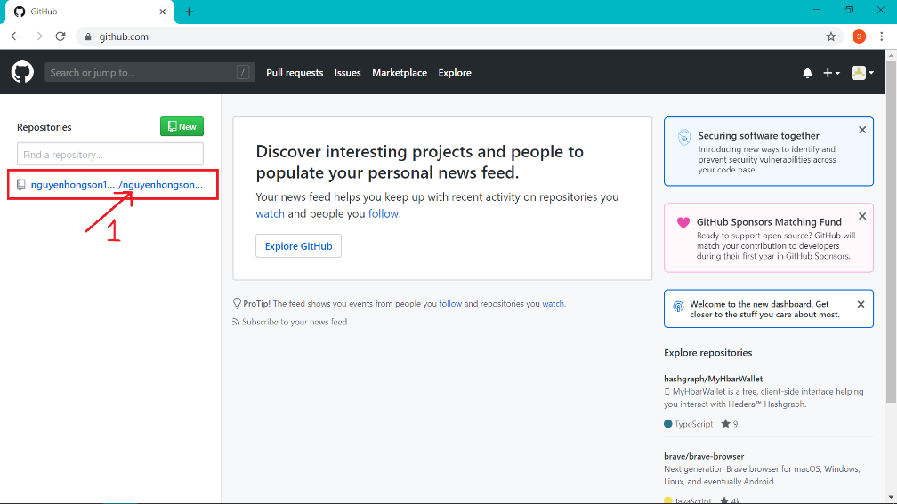

**Step 2**: Click on Upload files.

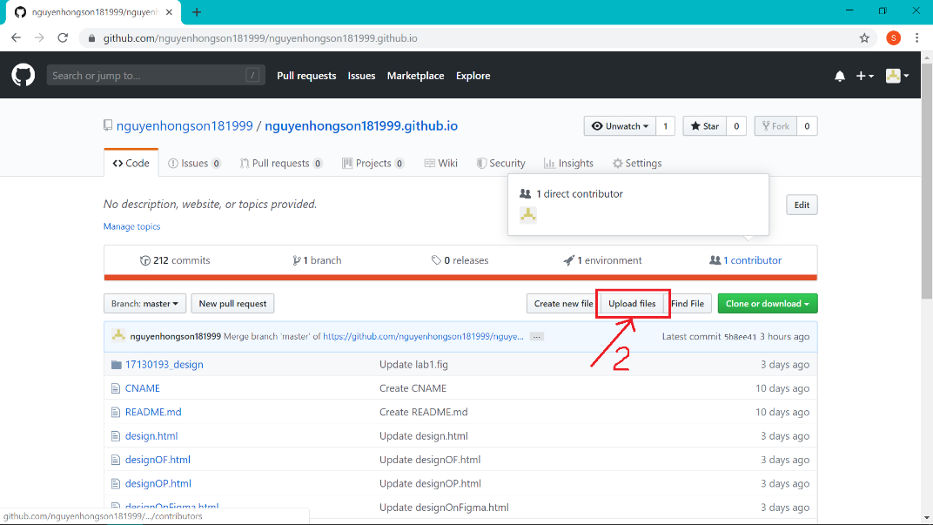

**Step 3**: Choose files on your desktop and open it.

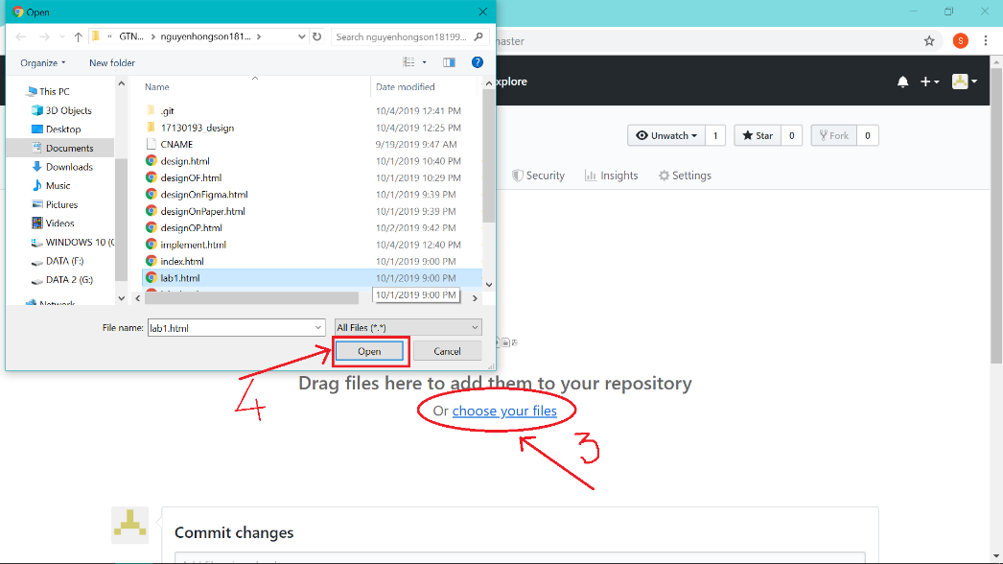

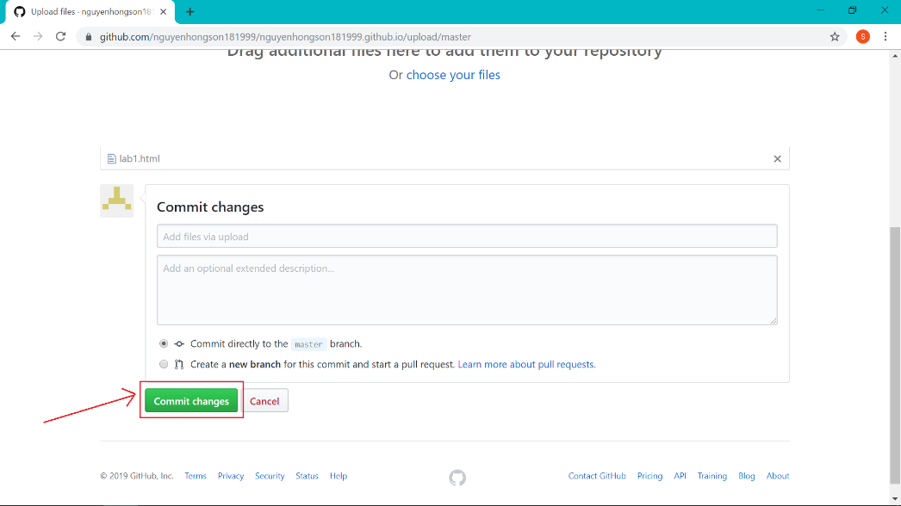**Step 4**: Click on button “Commit changes” to finish.

**2. How to upload files on GitHup on Desktop:**

**Step 1**: Click on icon GitHup on your screen.

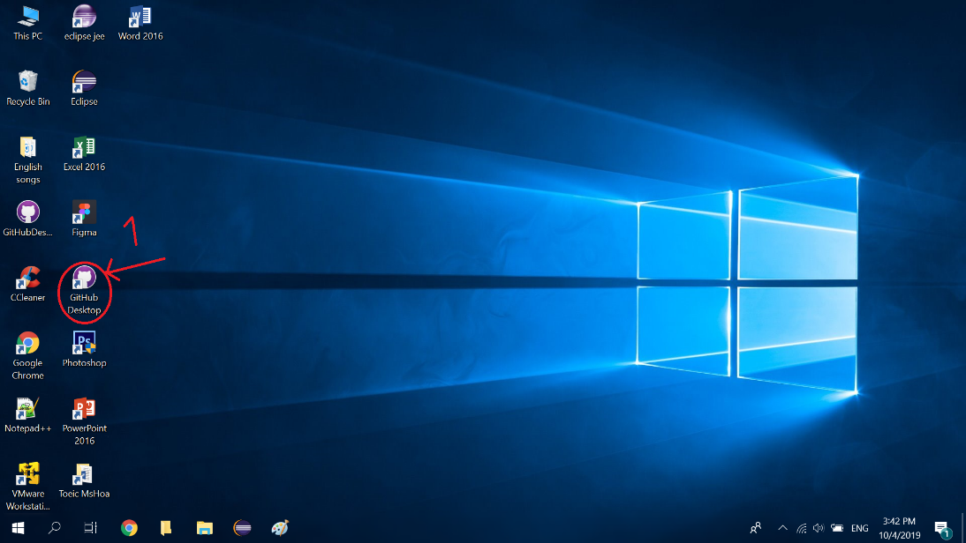

**Step 2**: Tick files that you want to upload and click button “Commit to master” to be continue.

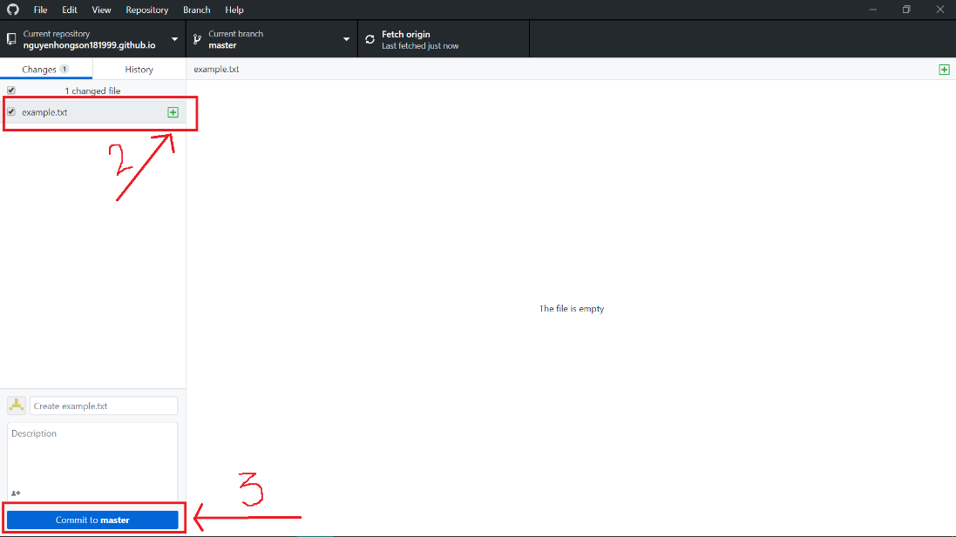

**Step 3**: Click on button “Push origin” to finish.

